INSTITUTIONAL MEMBERSHIP FORM

Philippine Organizations/Companies/Universities |  | PhP 7,500.00
Foreign Organizations/Companies/Universities |  | USD 200.00
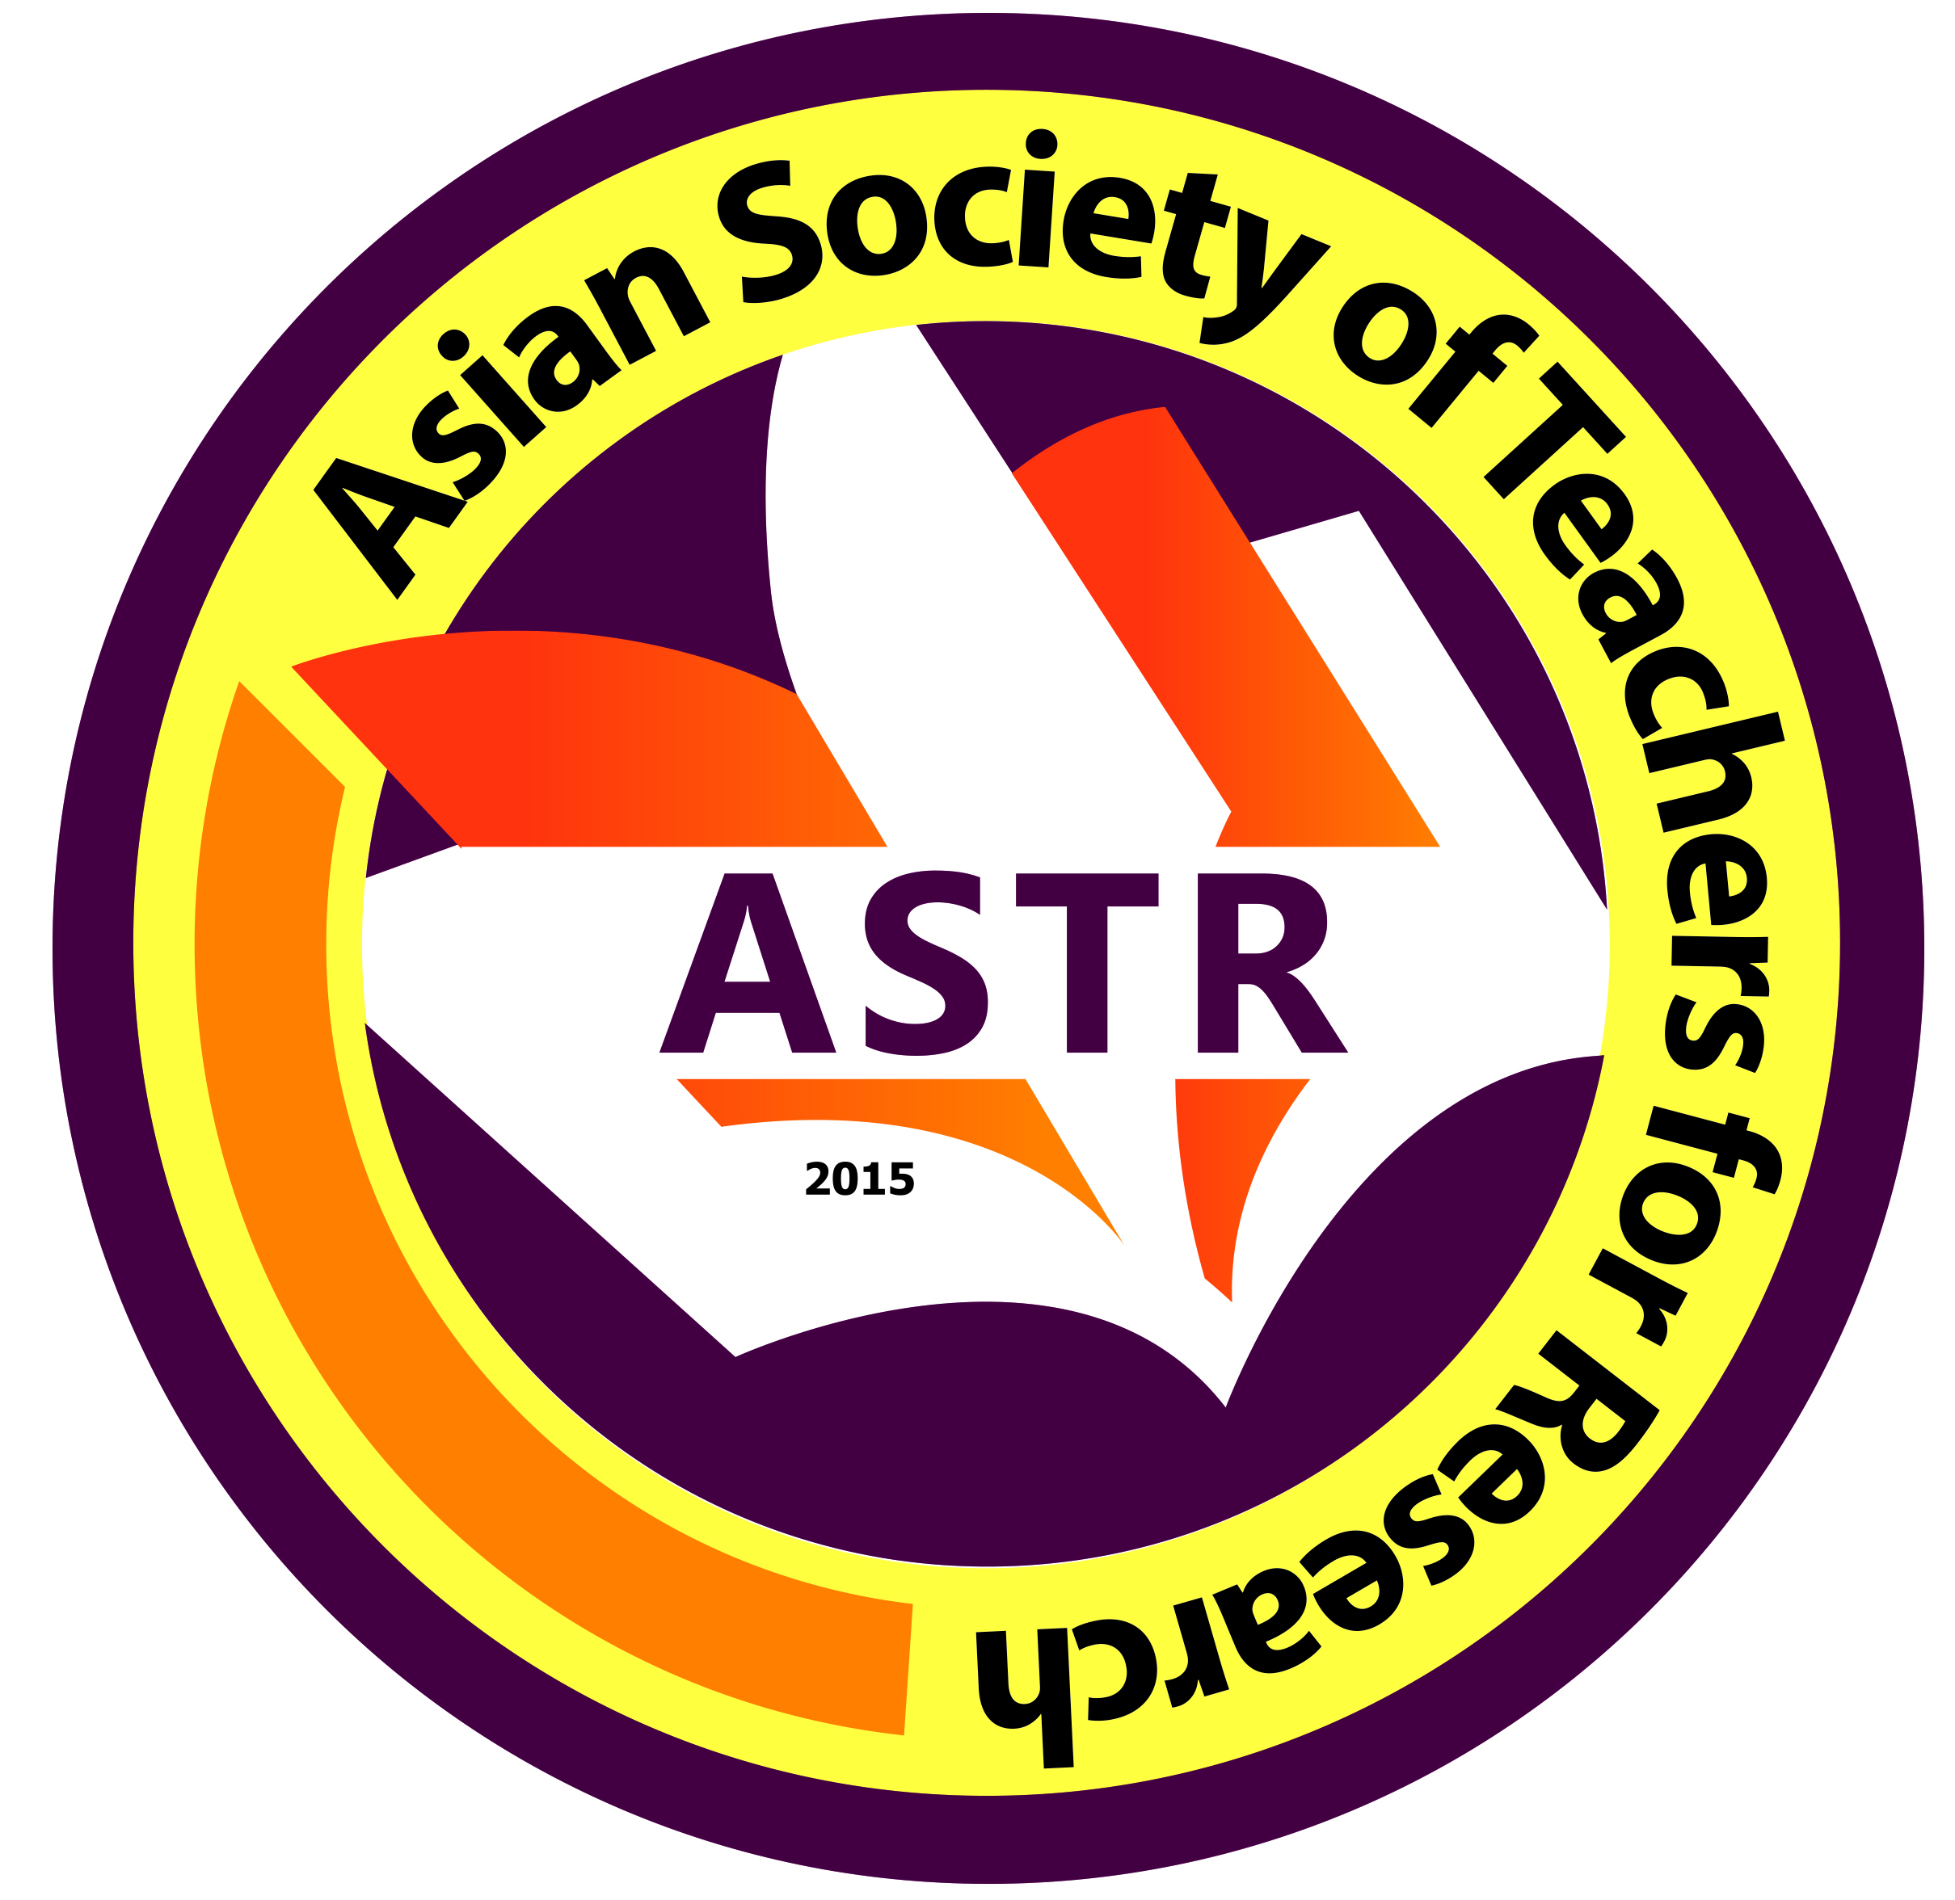
Date Filed: ________________
New Renewal

Organization/School/University:_______________________________________________________________
Address: ___________________________________________________________________________________________
Name of President/Administrator: _____________________________________________________________
Name of Research Director: ______________________________________________________________________
Name of Contact Person: ____________________________________ Email Address: __________________
Country: ____________________ Contact Number: __________________ Website: ______________________

List of Journals Print Online Refereed

1.
2.
3.

Please fill-out the form, scan, and send to astr@aseanresearch.org. You may also personally return the filled-out form to any personnel of ASTR, Inc.

ASTR BANK ACCOUNT
Name of Bank: Bank of the Philippine Islands
Address: Georgetown Cybermall, Cagayan de Oro City, Philippines
Account Name: Asian Society of Teachers for Research Inc
Account Number: 8991-0004-62 (PESO SAVINGS ACCOUNT)

About ASTR, Inc.

The Asian Society of Teachers for Research Inc. is an organization devoted to the advancement of pedagogy/andragogy in the teaching of research in all academic levels. Established in 2015, it has over 2100 members from the Philippines and all over Asia

